

**Bodalla Public School 1272**

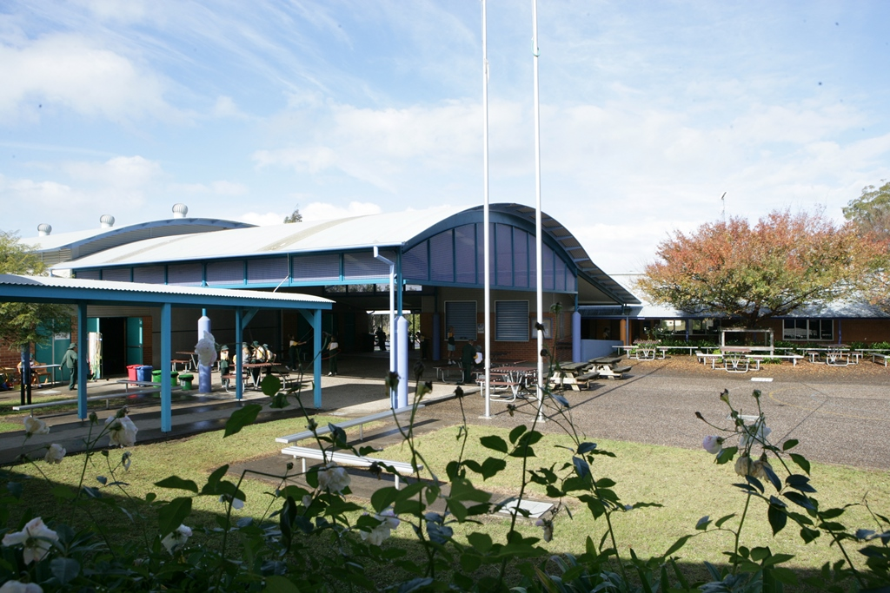

|  |  |  |  |  |
| --- | --- | --- | --- | --- |
|  | | | | |
| **School vision statement** |  | **School context** |  | **School planning process** |
| **Bodalla Public School is committed to providing high quality educational programs within an inclusive, respectful and caring environment.**  **We support students as they aim for continued improvement in their academic, physical, emotional and spiritual development in the pursuit of personal excellence.**  C:\Users\ltakacs1\AppData\Local\Microsoft\Windows\Temporary Internet Files\Content.Word\P1010435.jpg |  | **Bodalla Public School is a small school in a rural setting, with beautiful spacious grounds and modern school facilities. These include technologically enhanced learning spaces, specialist Literacy and Numeracy Centres, outdoor learning areas, a dedicated art studio, multi-purpose assembly hall, extensive playing fields and shaded play areas.**  Enrolment in 2016 is 93, remaining steady for the first time in 6 years. The school’s suspension rate is excellent, with no students being suspended in 2015. Students are cooperative and positive in their approach to learning and to each other. The school is characterised by its inclusiveness of all students and their diverse backgrounds, including 30% Aboriginal students and two students identified with moderate to high support needs.  The students are active participants in school decision making through the incorporation of a School Parliament into the school system. Student voice is heard regularly through this interactive forum between all students, the Parliamentary Team, teachers and the Principal enabling and promoting positive school action.  Kindy Start and, specialised Art and Music Programs are integral to the well-being of the students and support all students in self-expression, confidence building and promote inclusivity. They are also actively supported by all aspects of the parent community proving to be successful in their goals.  Bodalla Public School is an active member of two Community of Schools groups, as students have the option to attend either local High School. Through these partnerships the school has an active Transition to High School Program involving both High Schools on a year round basis with specialist classes in English, Drama and Mathematics. |  | Bodalla Public School engages in collaborative decision making that consults and engages with the school community to ensure planning and processes are reflective of the schools identified needs.  Students, staff and community actively participate in surveys that provide data about their views on the current programs and operations at Bodalla Public School. The school is working towards developing collaborative relationships with the newly established AECG and FSC network.  A school vision statement was developed collaboratively with community, students and staff. Staff meetings and an open community forums are conducted to develop and help shape the three strategic directions within the Bodalla context: 1. Curriculum and Assessment  2. Engagement and Attainment   1. Organisational Effectiveness   Feedback suggests that the school community is very happy with the community connections that have been established. The Art and Music Programs were identified as strengths in the school. These programs and connections need to be maintained in the future.  The community would like to see the further development of technology and associated training and opportunities for gifted and talented students.  Staff identified the school strengths as differentiated learning, the friendly atmosphere and great community. The music program is an asset to the school and valued by all involved. Technology upgrades and associated professional development were identified as areas for continued future development.  Trends from the surveys reveal that parents feel the Music and Art programs should continue. The Breakfast Program should be ongoing, technology needs to be utilised more, Aboriginal cultural awareness should be increased and the school should hold more community events. A significant number of students identified Bodalla Public School as a small friendly environment with excellent teachers and well-behaved students. |
|  |
|  |

|  |  |  |  |  |
| --- | --- | --- | --- | --- |
|  | | | | |
|  | | | | |
|  |  |  |  |  |
| **Purpose:**  **To ensure all aspects of new National Curriculum are embedded through Quality Teaching in all teaching and learning programs that are inclusive of all student needs through differentiation and reflective teaching practice.** |  | **Purpose:**  **To promote high level student engagement through quality teaching and learning utilising innovative teaching practices for 21st century learners and community engagement and partnerships enabling enhancement of student learning outcomes.** |  | **Purpose:**  **Implementation of innovative educational programs, organisational processes and leadership practices to successfully meet educational needs of students, leadership development of teachers, community and systemic requirements effectively and efficiently.** |

|  |  |  |  |  |  |  |
| --- | --- | --- | --- | --- | --- | --- |
| Strategic Direction 1: Curriculum and Assessment | | | | | | |
|  | | | | | | |
| **Purpose** |  | **People** |  | **Processes** |  | **Products and Practices** |
| To ensure all aspects of new National Curriculum are embedded through Quality Teaching in all teaching and learning programs that also are inclusive of all student needs through differentiation and reflective teaching practice. |  | **Students:**   * will be actively engaged in 21st century learning, developing their capacity to be reflective self-directed learners that are able to utilise own and others feedback to set goals and develop learning plans. * not meeting National Minimum standards, and Aboriginal students not meeting the achievements of their peers, will have access to learning support programs in literacy and numeracy.   **Staff:**   * collaboratively employs reflective teaching practices to provide feedback to each other on quality teaching practices and feedback to students on Literacy and Numeracy learning aligned to the continuums. * plan for, design and implement quality teaching and learning programs that demonstrate inclusion of new curriculum elements, differentiation reflective of individual student needs for personalised learning.   **Parents:**   * engage in learning through the sharing of knowledge and active participation in workshops and forums to enhance understanding of new curriculum requirements and literacy and numeracy strategies to support student acquisition of outcomes.   **Community Partners:**   * maintain and consolidate links and networks with both Moruya and Narooma Community of Schools, as well as Eurobodalla Learning Community for curriculum sharing and continuity of teaching and learning.   **Leaders**:   * coach staff to set professional learning goals to increase teaching capacity and enhance student outcome acquisition in literacy and numeracy. |  | * Shared programming and planning practices to inform scope and sequence development and implementation as well as consistent teaching of curriculum, literacy and numeracy K-6. * Collaborative development of assessment schedule to inform planning and programming that is evidence based and reflective of student context. * Continuous assessment practices in Literacy and Numeracy supported by all school staff and data analysis every term in line with the tracking of and analysis of school data processes. * Professional learning on assessment practices and moderation activities. Staff to complete moderation tasks as part of ongoing tracking and monitoring of teaching practice and student achievement. * Staff and students use rubrics to assess work and drive improvement through reflective practices. * TOWN and TEN trainers to coach and support other staff to assess and implement programs. * The MultiLit suite of Programs is used to support reading improvement of students through targeted intervention K-2. * Professional learning as part of the CoS – Narooma in writing as part of Writing in the Middle Years project to focus on consistency in teaching, learning and assessment practices across schools and measure student achievement.   **Evaluation Plan**  **Internal –** Reporting against milestones, internal data, lesson observations, feedback.  **External –** External assessment results. |  | **Products**:   * Clear evidenced based teaching and learning tasks linked to Scope and Sequences in English, mathematics, science and technology, and history that reflect the new NSW Syllabus requirements and reflect Literacy and Numeracy Continuum clusters and milestones. * Clearly defined Scope and Sequence documents map learning and assessment for, as and of learning from K-6 to inform tracking of student achievement. * Survey data identifies that 100% of teachers follow the schools Scope and Sequence for assessment, understand, have confidence in using and link to teaching practice Literacy and Numeracy Continuums, including the PLAN tracking information, Ten and TOWN.   **Practices**:   * There is a school-wide, collective responsibility for student learning and success, with high levels of student, staff and community engagement through the sharing of expertise and teaching practice. * Whole school sharing of practice and consistency of assessment when tracking students on the continuum. * Student achievement K-6 data tracked and evaluated using PLAN and PLP’s. * K-2 understanding and implementation of Ten, Synthetic Phonics and MiniLit. * 3-6 understanding and implementation of TOWN, SpellIt, MutliLit, MutliLit Extension. * Reflective teaching practice utilised by students and staff to provide constructive feedback for the purpose of self-evaluation, sharing of professional practice and facilitation of learning plans for both staff and students. * Student learning, teaching, tracking and assessment of writing consistent between community partners enhancing student achievement of outcomes. * The school continually develops policies, programs and processes that identify, address and monitor student learning needs. |
| **Improvement Measures** |  |
| * In 2015 Kindergarten to Year 2 staff will actively use the Literacy and Numeracy Continuums to assess and track student learning and implement knowledge gained to plan for future learning. * In 2016 all staff will actively use the Literacy and Numeracy Continuums to assess and track student learning and implement knowledge gained to plan for future learning and provide feedback to students to assist with development of individualised learning plans. * By 2017 there will be a K-6 Scope and Sequence of integrated learning tasks actively employed by teachers that enhance student acquisition of outcomes in English, mathematics, Science and Technology and History. * By 2016 survey data shows staff follow a Scope and Sequence of assessment tasks in Literacy and Numeracy for the purpose of planning of future learning for students. |  |

|  |  |  |  |  |  |  |
| --- | --- | --- | --- | --- | --- | --- |
| Strategic Direction 2: Engagement and Attainment | | | | | | |
|  | | | | | | |
| **Purpose** |  | **People** |  | **Processes** |  | **Products and Practices** |
| **To promote high level student engagement through quality teaching and learning utilising innovative teaching practices for 21st century learners and community engagement and partnerships enabling enhancement of student learning outcomes.** |  | **Students:**   * engage in meaningful learning opportunities that support wellbeing and healthy mind and body lifestyles. * actively engage in innovative 21st century learning styles that reflect the technological world and enable them to work collaboratively, creatively, critically and engender in them responsibility as learners.   **Staff:**   * explicitly teach 21st century learning skills including technology, collaboration and wellbeing promoting engagement in learning and balanced lifestyles. * engage in self awareness and professional learning to promote a heightened understanding of wellbeing and relationship with engagement in learning.   **Parentsand Community:**   * are involved in whole school practices that promote engagement and student wellbeing both within school context and home context. * are provided with opportunities to actively participate in all areas of school life. * establishment and development of partnerships to promote transition and engagement in the development of innovative 21st century programs that enable high level success.   **Leaders:**   * actively coach staff to enable engagement in National Standards for Teachers and individualised goal setting reflecting innovative 21st century quality teaching practice. * actively engage with CoS – Narooma and Moruya for Transition to High School and with local feeder Preschools for Kindy Start. |  | * Programming and planning processes around the inclusion of the Learning Across the Curriculum elements of: critical and creative thinking, information and communication technology capability, personal and social capability in teaching and learning practices including Scope and Sequences. * Shared planning and reflective practices to build teacher and student capacity that has a strong focus on 21st century learning. * Implementation of a whole-school approach to wellbeing that has clearly defined behavioural expectations and creates a positive teaching and learning environment. * Staff facilitate parent information sessions that promote community and parent partnerships to enhance student engagement through positive respectful partnerships, wellbeing and ensure good conditions for student learning through programs such as Transition to School and High School, Friends(KidsMatter), Breakfast Club, Homework Centre, Live Life Well @ School, Mindfulness and Kitchen Garden. * Staff engagement in professional learning around the arts (Visual and Music) for the development of programs that promote wellbeing and student engagement. * Professional learning for staff and implementation of Friends, Fun Friends and Mindfulness programs to drive improvement in student engagement and wellbeing.   **Evaluation Plan**  **Internal –** Reporting against milestones, , lesson observations, feedback from staff and students through surveys.  **External –** Parent and community data collected through surveys and community forums. Engagement of critical friend to review school. |  | **Products**   * Learning Across the Curriculum elements: critical and creative thinking, information and communication technology capability, personal and social capability embedded in programs in all Key learning Areas. * Clearly defined scope and sequence documents for Information Communication Technology skills and capabilities. * Whole school program for student wellbeing – mindfulness, mental and physical health. * Scope and Sequence for the teaching of the arts – Music and Visual that incorporates evidenced based activities for the promotion of wellbeing and 21st century skills and capabilities. * The school has a framework that is comprehensive and inclusive and supports the cognitive, emotional, social, physical and spiritual wellbeing of students, which measurably improves individual and collective wellbeing.   **Practices**   * Staff and students demonstrate confidence as 21st century learners in a technological world through use of ICT and fundamental skills including innovation, creativity and critical thinking. * Explicit and effective implementation of wellbeing programs across the school for both staff and students. * Strong transitions with Narooma and Moruya CoS, local Preschools that engages staff, students and community including meaningful and effective transfer of information and ongoing monitoring. * The school establishes active partnerships and works collaboratively to ensure continuity of learning for students. * Extra- curricular learning opportunities are significant, support student development and are strongly aligned with the school’s vision, values and priorities. |
| **Improvement Measures** |  |
| * Using the Quality of School Life student survey results indicate that most students display an overall positive view about school life including general satisfaction at school, strong sense of achievement, positive sense of adventure in learning, relevance of schooling and positive student-teacher relationships. The majority of students also give positive ratings in relation to their status, self-esteem and social integration. * In 2016 staff teaching and learning programs will include Learning Across the Curriculum elements critical and creative thinking, information and communication technology capability, personal and social capability demonstrating understanding of 21st century skills and capabilities. * In 2015 all classes will implement wellbeing programs for the purpose of student engagement and be measured through surveys. * Parent surveys will indicate increased engagement with school programs and processes. |  |

|  |  |  |  |  |  |  |
| --- | --- | --- | --- | --- | --- | --- |
| Strategic Direction 3: Organisational Effectiveness. | | | | | | |
|  | | | | | | |
| **Purpose** |  | **People** |  | **Processes** |  | **Products and Practices** |
| **Implementation of innovative educational programs, organisational processes and leadership practices to successfully meet educational needs of students, leadership development of teachers, community and systemic requirements effectively and efficiently.** |  | **Students:**   * as leaders collaboratively plan with staff programs for school improvement and provide feedback on programs to enhance future planning and programming.   **Staff**:   * actively engage in learning community systems to support accreditation and performance and leadership development. * actively engaged in coaching processes for the development of professional learning programs to meet the requirements of the National Standards for teaching.   **Parents and Community:**   * provided with opportunities at a school and Community of Schools level to engage with education both formally and informally for the promotion of personal development, student outcome enhancement and development of leadership skills and capabilities. * development of collective capacity to implement programs for student enhancement and staff leadership skill development. * provided with opportunities to actively participate in school planning and program implementation processes for the benefit of students, including cultural programs and local school context programs.   **Leaders**:   * School leaders are engaged as active and engaged members of the Eurobodalla Learning Community, Narooma CoS, Moruya CoS and Far South Coast Principal’s network. |  | * Effective utilisation of school parliament program to support and enhance student engagement in school planning and leadership capacity building through coaching and skill development. * Coaching – engage all staff in developing a deeper understanding of effective coaching through active participation in coaching program for personal goal setting and learning as well as supporting colleagues with personal goal setting and professional learning. Aligned to Teacher Performance Development Framework. * Shared and active engagement of all staff in distributed leadership processes to further develop leadership capacity across whole school and sustain improvements in teaching and learning. * Development of school community engagement strategies for increased communication between parents, community and school for school planning, implementation of programs and parent leadership in educational, cultural and wellbeing programs including MultiLit, Breakfast Program, Kitchen Garden and Aboriginal Education Programs.   **Evaluation Plan**  **Internal –** Reporting against milestones, focus group sessions, evaluation of Personal Learning Plans, and feedback from staff and students through surveys.  **External –** Parent and community data collected through surveys and community forums accessed through School Map. |  | **Products**   * AITSL and DEC (Teacher Performance Development Framework) resources are actively utilised by all staff to support teacher professional learning, promote leadership opportunities and enable best practice. * Strategic organisation and programming documents to ensure shared professional practice opportunities are engaged with and beneficial to all participants, including observation, coaching and feedback. * Student and staff participation in all CoS and ELC opportunities as both participants and leaders. * Breakfast, Kitchen Garden and Aboriginal Education programs being managed and implemented by parents and community.   **Practices**   * Staff working collaboratively to support Accreditation processes at all levels of the National Standards for Teachers; also for the Teacher Performance Development Framework. * AITSL and DEC resources used by teachers as a tool to continuously self-monitor and measure own performance and development for the self-improvement and support of colleagues development. * School Plan and Programs developed and implemented by parent, community, student and staff as partners in education. * School capacity is increased through practices that are embedded for parents to be engaged and understand the learning progress of their children and how to effectively support them to learn including cultural and social programs. * Practices and processes are responsive to school community feedback through regular engagement with parents and community about all aspects of school community life. |
| **Improvement Measures** |  |
| * All staff use AITSL accreditation resources to support performance, development and coaching sessions. * School will demonstrate 100% active participation in CoS and ELC networks for the purpose of enhancing student outcome attainment, teacher professional learning and leadership opportunities. * All staff indicates understanding and commitment to Performance and Development – including accreditation aligned to National Teaching Standards and performance Development Framework. * School Map parent and student surveys indicate a 100% increase in the participation of parents and students in the school in decision making, school planning and culture of the school. (Baseline data from Parent Forum 2014 – 1 participant). |  |